Aclean Dapps

Group 02

* Kevin Sorensen (00000062002)
* Adhitya Bagus Wicaksono (00000048211)

# Introduction and Background

Throughout the world, air conditioners are widely used to keep interior temperatures agreeable, particularly in warmer climes. For air conditioning machines to operate efficiently, last a long time, and avoid expensive and annoying breakdowns, regular maintenance is essential. Thus, maintenance, installation, cleaning, and replenishing of refrigerant are crucial services for air conditioning systems. However, in dealings between clients and service providers, trust and transparency concerns frequently surface. Utilizing blockchain technology as a remedy provides a way to change conventional corporate procedures by bringing in a more transparent, safe, and effective system. This technology increases transparency and fosters greater confidence among all parties involved by recording every transaction in an everlasting and unchangeable ledger.

Effective decentralization is made possible by the use of blockchain in a Service Marketplace application, which eliminates the need for middlemen like banks or other payment platforms. This lowers transaction costs and expedites the payment process by enabling service providers to communicate directly with clients. Furthermore, blockchain's high security provides robust defence against hacking attempts and data tampering because it distributes and encrypts data across networks. Additionally, this program incorporates a safe and unique login function that uses a MetaMask address to verify user identity in lieu of conventional personal data, enhancing privacy and security.

By introducing automation capabilities for service contracts and guaranteeing that payments are only executed once all contract criteria are satisfied, the implementation of smart contracts on Ethereum lowers the possibility of fraud. In addition to making login easier, the connection with MetaMask improves user identity security and integrity throughout every transaction. Blockchain is a great option for applications that need to maintain high levels of data integrity and openness because of these benefits. As a result, by guaranteeing justice and confidence in each transaction, integrating blockchain technology into the AC service platform not only streamlines corporate procedures but also improves the rapport between suppliers and customers.

# Design

This chapter outlines the architecture and operations of the Decentralized Service Marketplace for air conditioner maintenance services, utilizing the Ethereum blockchain and smart contracts to automate and secure transactions, ensuring a safe and trustworthy environment for service providers and customers.

## Introduction

This chapter outlines the architecture and operations of the Decentralized Service Marketplace for air conditioner maintenance services, utilizing the Ethereum blockchain and smart contracts to automate and secure transactions, ensuring a safe and trustworthy environment for service providers and customers.

## Product Flow

The product flow details every step of user interaction with the platform, from initial access to transaction completion:

1. Initial Requirements

* Users must use a browser compatible with wallets such as the MetaMask extension.

1. Login with MetaMask

* Authenticates users' identities using MetaMask, connecting them to the application via their Ethereum address.

1. Exploring and Selecting Services

* After login, users can view a list of available AC services along with detailed descriptions, costs, and other pertinent details.

1. Service Booking

* Users fill out a detailed booking form and make payments which are held in a smart contract marked as "Pending".

1. Order Management by Service Providers

* Service providers can start the order by clicking "start order", changing the status to "In Progress".
* "Complete order" appears for customers to confirm completion of the service.

1. Transactions and Payments

* Payments are transferred to the service provider's wallet upon confirmation of service completion.

1. Becoming a Service Provider

* Users can register as service providers by filling out a service provider form, noting that they cannot order services from themselves.

## On-chain and Off-chain Components

* **On-chain**: Smart contracts for managing services, orders, and payments.
* **Off-chain**: User interface built with React and Chakra UI, providing intuitive and responsive interactions, facilitated by Web3.js communication.

## Development and Testing Setup

1. Truffle

* Truffle is a development framework for Ethereum that facilitates lifecycle management of smart contracts, including compilation, testing, and deployment.
* To Install Truffle, open a terminal and run the following command:



* This installs Truffle globally on your machine, allowing you to access it from any directory.

1. Ganache

* Ganache provides a personal Ethereum blockchain for testing and development purposes. It allows developers to execute projects without spending real gas and to operate in an isolated environment.
* Ganache can be downloaded from the Truffle website. Please visit the following link to download:

<https://archive.trufflesuite.com/ganache/>

* Ganache Configuration:

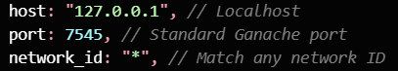

## User Interaction Flow

* **User Interaction Flow**: A flowchart detailing the process from user login, service selection, payment, service receipt, and confirmation of completion.

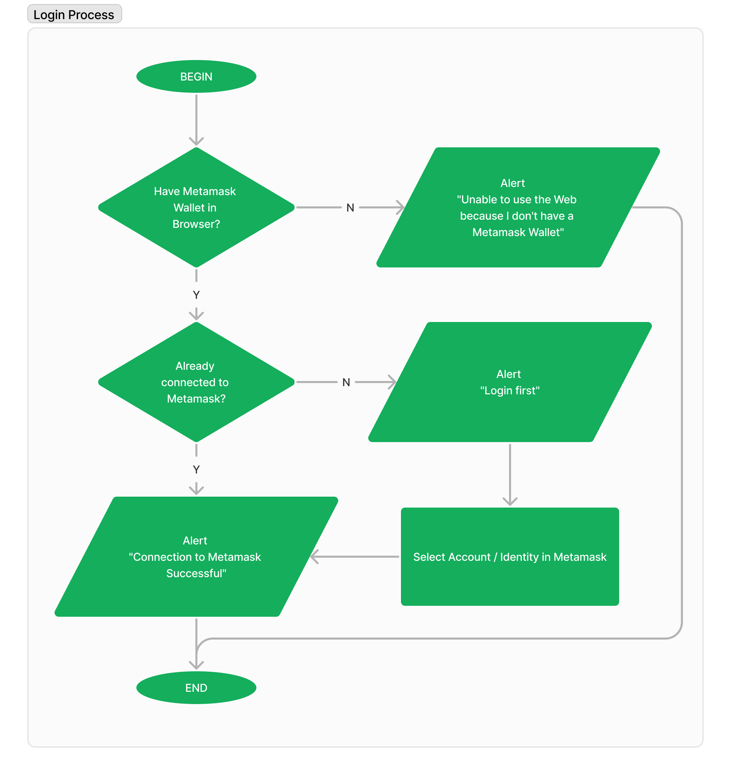

Image 2.1 Login Process

The flowchart you provided illustrates the login process for a web application that utilizes the Metamask cryptocurrency wallet extension. The process begins by checking if the user has the Metamask wallet extension installed in their browser. If the wallet is not detected, an alert is displayed informing the user that they cannot proceed without Metamask. Assuming the user has Metamask installed, the flowchart next checks if the user is already connected to their Metamask wallet within the current browser session. If the user is already connected, an alert is displayed confirming successful connection to Metamask. If the user is not already connected to Metamask, the flowchart prompts the user to select their desired account or identity within the Metamask extension. Once the user has selected their account, the login process is complete.

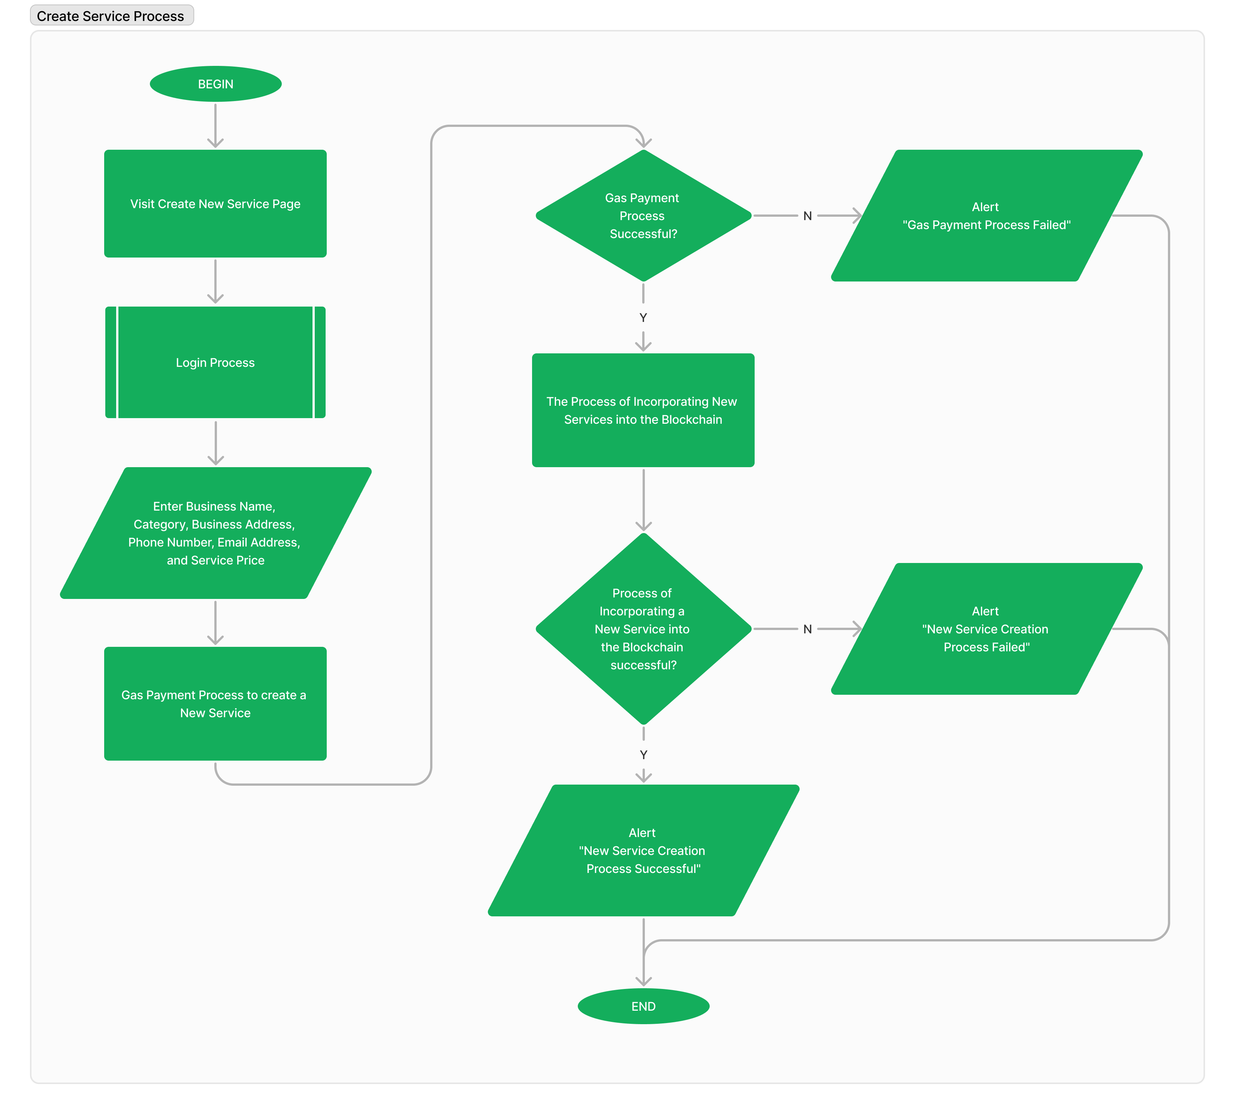

Image 2.2 Create Service Process

The flowchart depicts the process of creating a new service on a blockchain platform. The process begins by visiting the "Create New Service" page. The user is then prompted to enter the business name, category, address, phone number, email address, and service price. Once this information is entered, the system checks if the gas payment process to create a new service is successful. If the payment is successful, the new service is incorporated into the blockchain and an alert message is displayed indicating that the service creation process was successful. If the payment fails, an alert message is displayed indicating that the service creation process failed.

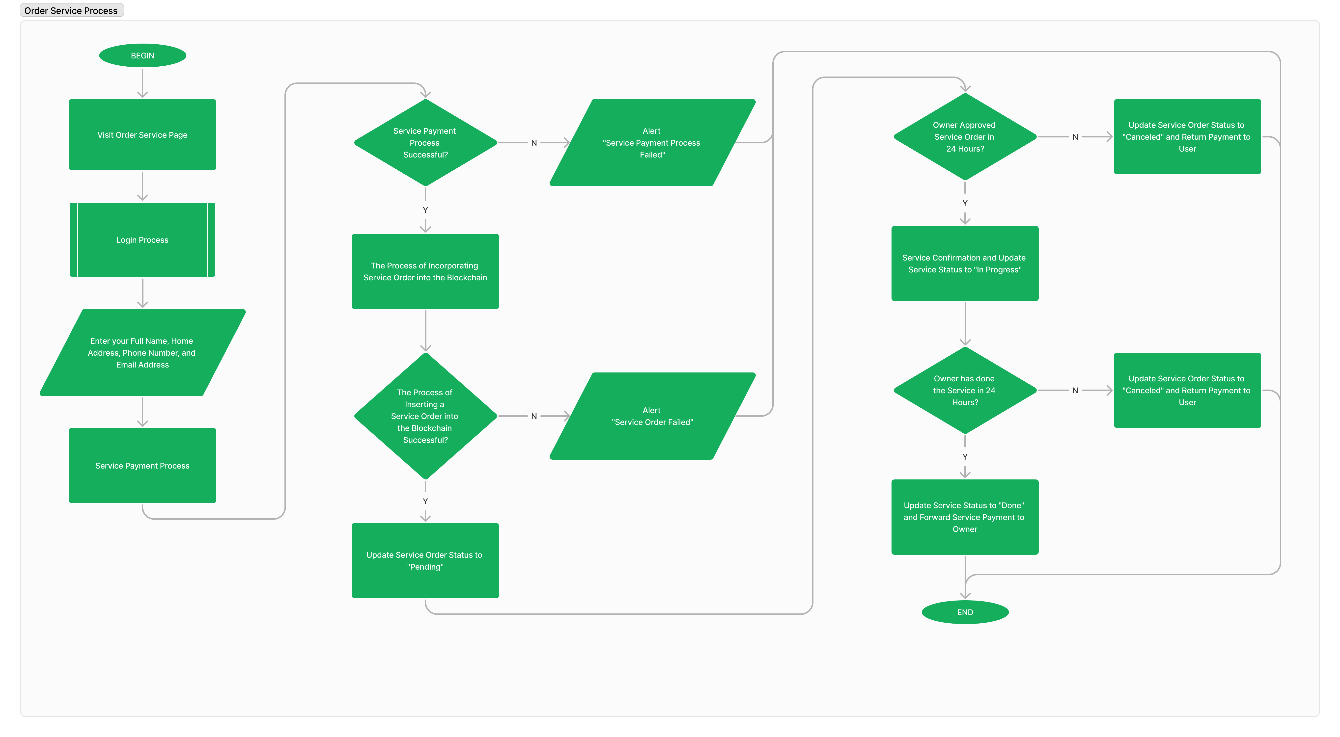

Image 2.3 Order Service Process

The flowchart you provided illustrates the process of ordering an AC maintenance service on a blockchain-based platform. The process begins by the customer visiting the platform and selecting the "Order Service" option. The customer is then prompted to enter their personal information, including their full name, phone number, and email address. Next, the customer selects the desired AC maintenance service from the available options and specifies the date and time of the service. Once this information is entered, the system calculates the total cost of the service. The customer then initiates the payment process using their cryptocurrency wallet. The system verifies the payment transaction and, upon successful payment, creates a new service order on the blockchain. The customer receives a confirmation message and the service provider is notified of the new order. The service provider reviews the order details and accepts the service request. Once the service is completed, the service provider marks the order as complete on the blockchain. The customer receives a notification that the service is complete.

## System Architecture

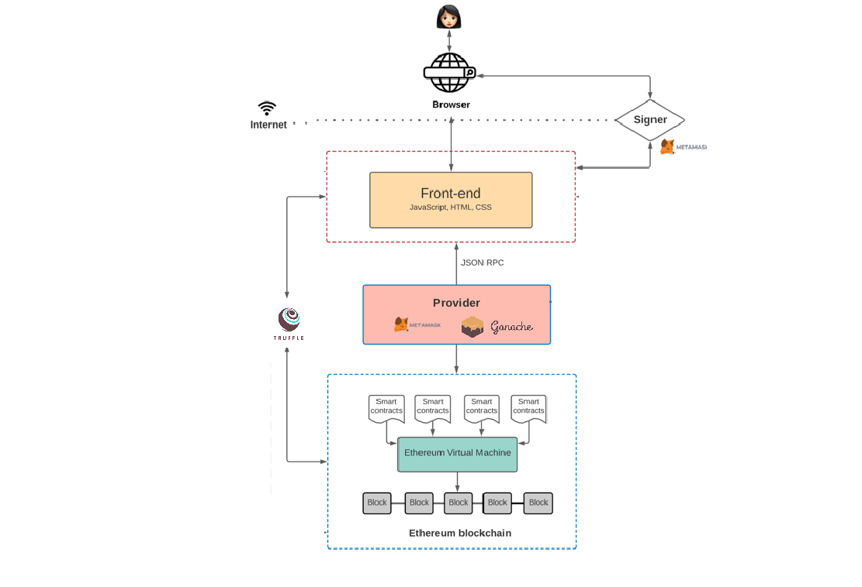

Image 2.4 System Architecture

The architecture of the AClean decentralized application (dApp) incorporates a streamlined interface between the user-facing front-end and the Ethereum blockchain, leveraging advanced web technologies and blockchain-specific tools. The front-end, crafted using JavaScript, HTML, and CSS, is designed to offer a responsive and intuitive user experience. Users interact with this interface through their web browsers, facilitated by MetaMask, a critical component that acts as a digital wallet and a gateway, allowing users to securely interact with the Ethereum network without compromising their private keys.

MetaMask serves as both a wallet and a provider, handling all blockchain transactions initiated from the front-end. It confirms users' actions by requiring them to authenticate and approve transactions, thereby signing and sending these transactions to the Ethereum blockchain. This setup is crucial for maintaining security as it decentralizes the risk associated with transaction handling by keeping private keys stored locally on the user's device, never exposing them to the online environment.

For development and testing, the architecture utilizes Ganache, a part of the Truffle suite, as a local blockchain simulation. This allows developers to deploy and test smart contracts in a controlled environment before they are live on the Ethereum mainnet, ensuring that all functionalities are thoroughly vetted. Truffle framework aids in smart contract management throughout the development lifecycle, simplifying tasks like deployment, interaction, and testing. By integrating these tools, AClean ensures a robust, secure, and efficient operational framework, making the platform reliable and user-friendly for both service providers and customers.

# Prototype

This section introduces the prototype of the application, emphasizing its role in visualizing and testing the concepts outlined in Section II. The prototype acts as a bridge between the initial design and the final product, providing stakeholders with a tangible representation of the application.

## Navigation Bar



Image 3.2 Navigation Bar

The navigation bar is a crucial component designed to facilitate easy user movement throughout the application. It includes several essential elements :

1. Application Logo (“Aclean”)

This is typically positioned at the top-left corner of the navigation bar. In the AClean application, the logo serves a dual purpose. Not only does it reinforce brand recognition, but it also functions as a clickable element that returns users to the home page at any time, providing a quick way to reset the navigation.

1. Navigation Menu

This is the core of the navigation bar, consisting of several key links that users will frequently use:

* **Home Page**: Directs users back to the main dashboard where they can browse or search for various services offered by other users, ensuring easy access to the core functionalities of the application.
* **Transaction History**: Allows users to view a detailed log of their transactions, helping them keep track of purchases, sales, or any financial interactions within the app.
* **My Service**: Specifically for users who are also service providers, this link takes them to a page where they can manage their offered services. Here, they can add new services, and edit or delete existing ones.
* **About Us**: Provides detailed information about the AClean platform, its mission, the team behind it, and other corporate information that can help build trust and engagement with the users.

1. Connect To Wallet

A crucial feature for a blockchain-based service marketplace, this button allows users to connect their digital wallets (such as MetaMask). This connection is essential for enabling transactions and interactions with the blockchain, providing a secure and efficient way to manage financial transactions directly within the application.

* Before Connected To Metamask :



Image 3.2 Before Conencted To Metamask

* After Connected To Metamask :



Image 3.3 After Conencted To Metamask

## Pages

Each page within the application is designed to offer specific functionalities and content that enhance the user experience:

1. **Home Page**: The landing page of the application after a user logs in. It provides a welcoming interface, showcasing various available services from other users. Features such as search bars, category filters, and featured services help users find what they need quickly and efficiently.

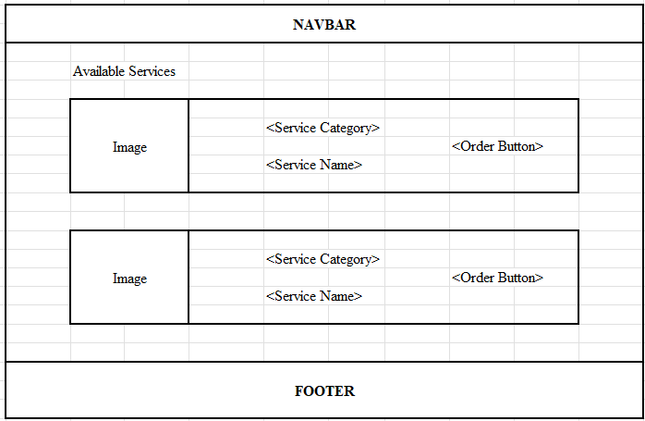

Image 3.4 Home Page

1. **Transaction History**: This page is vital for users who need to monitor their financial activities within the application. It includes detailed lists of past transactions, with functionalities such as sorting and filtering to help users easily navigate through their financial records.

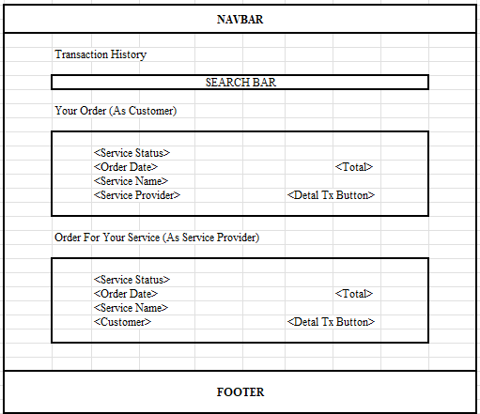

Image 3.5 Transaction History Page

1. **My Service**: This is a dedicated area for service providers to manage their offerings. It includes tools for posting new services, updating details about existing services, and tracking current engagements. It’s designed to be user-friendly and comprehensive, ensuring providers can fully manage their offerings.

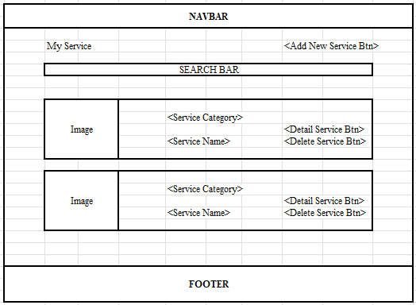

Image 3.6 My Service Page

1. **About Us**: This page is intended to provide users with more information about the AClean platform. It includes the platform’s history, goals, team information, and possibly user testimonials. It serves as a resource for users and potential stakeholders to learn more about the values and the people behind AClean.

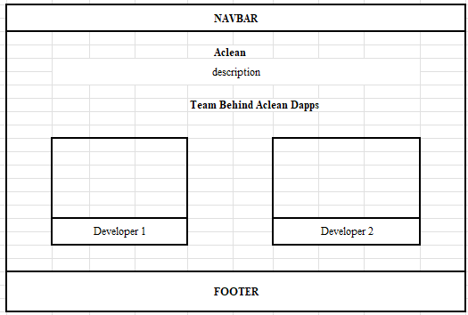

Image 3.7 About Us Page

# Result

# The following is a screenshot of the Application Implementation results :

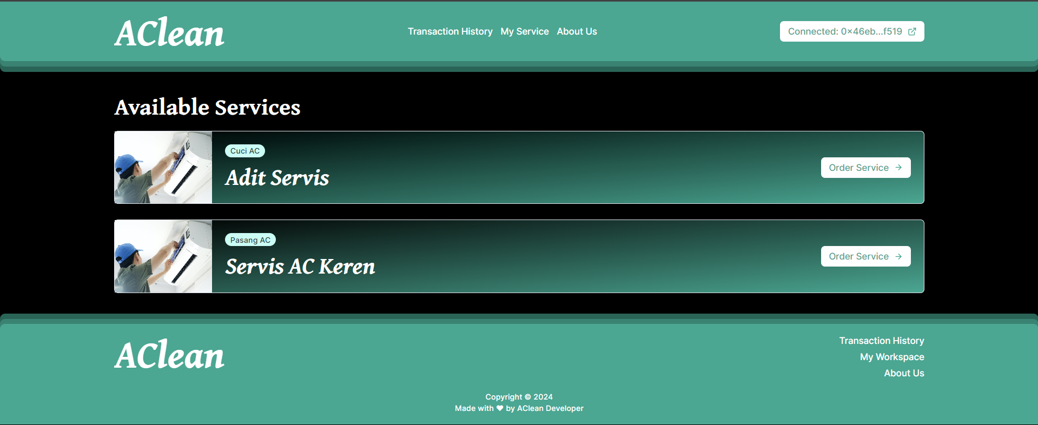

Image 4.1 Home Page Result

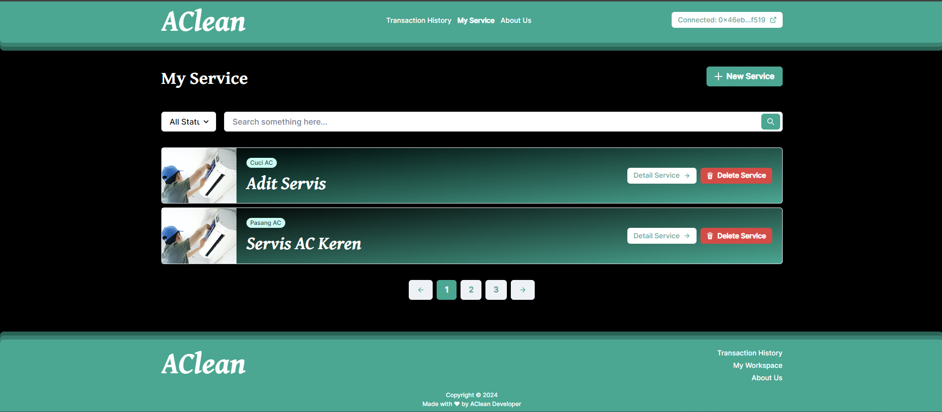

Image 4.2 My Service Result

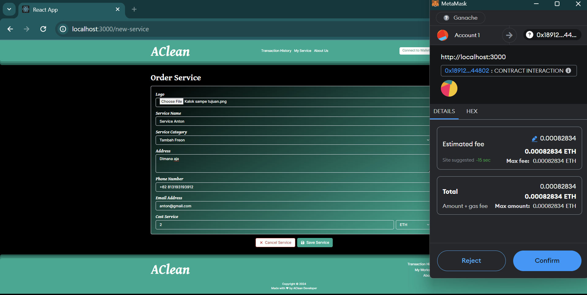

Image 4.3 Create New Service

Image 4.1 depicts the main interface of the AClean application, where users can browse various available services, each listed with a description and an "Order Service" button for convenient transaction initiation. Image 4.2 shows the management page for service providers, providing tools to view, detail, delete, and add new services, complete with pagination and search functions for effective management. Image 4.3 illustrates the form used by providers to add new services, including fields for service details, contact information, and a logo upload, with integration of MetaMask for secure blockchain transactions, ensuring all data is properly recorded and maintained.

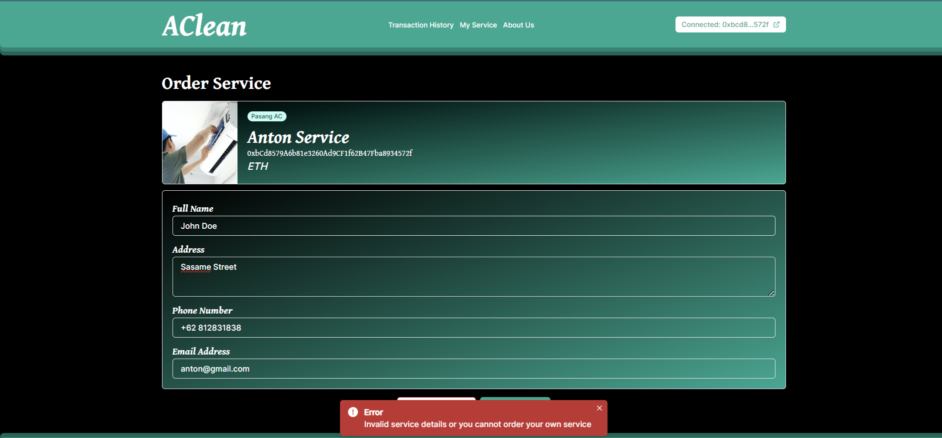

Image 4.4 Can’t Order Own Service

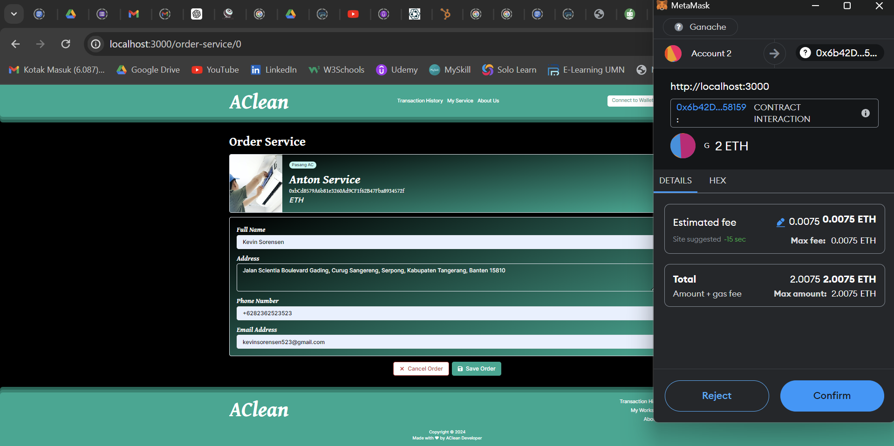

Image 4.5 Order A Service

Image 4.4 shows the AClean application's error handling where a user is prevented from ordering their own service, displaying a message that emphasizes the prohibition of self-service to ensure fairness. Image 4.5 illustrates a user ordering a service from another provider, detailing the provider's information and requiring user contact details with a MetaMask transaction confirmation pop-up. This interaction showcases the seamless integration of blockchain technology for secure and transparent transactions within the AClean platform, reinforcing the system's integrity and user trust.

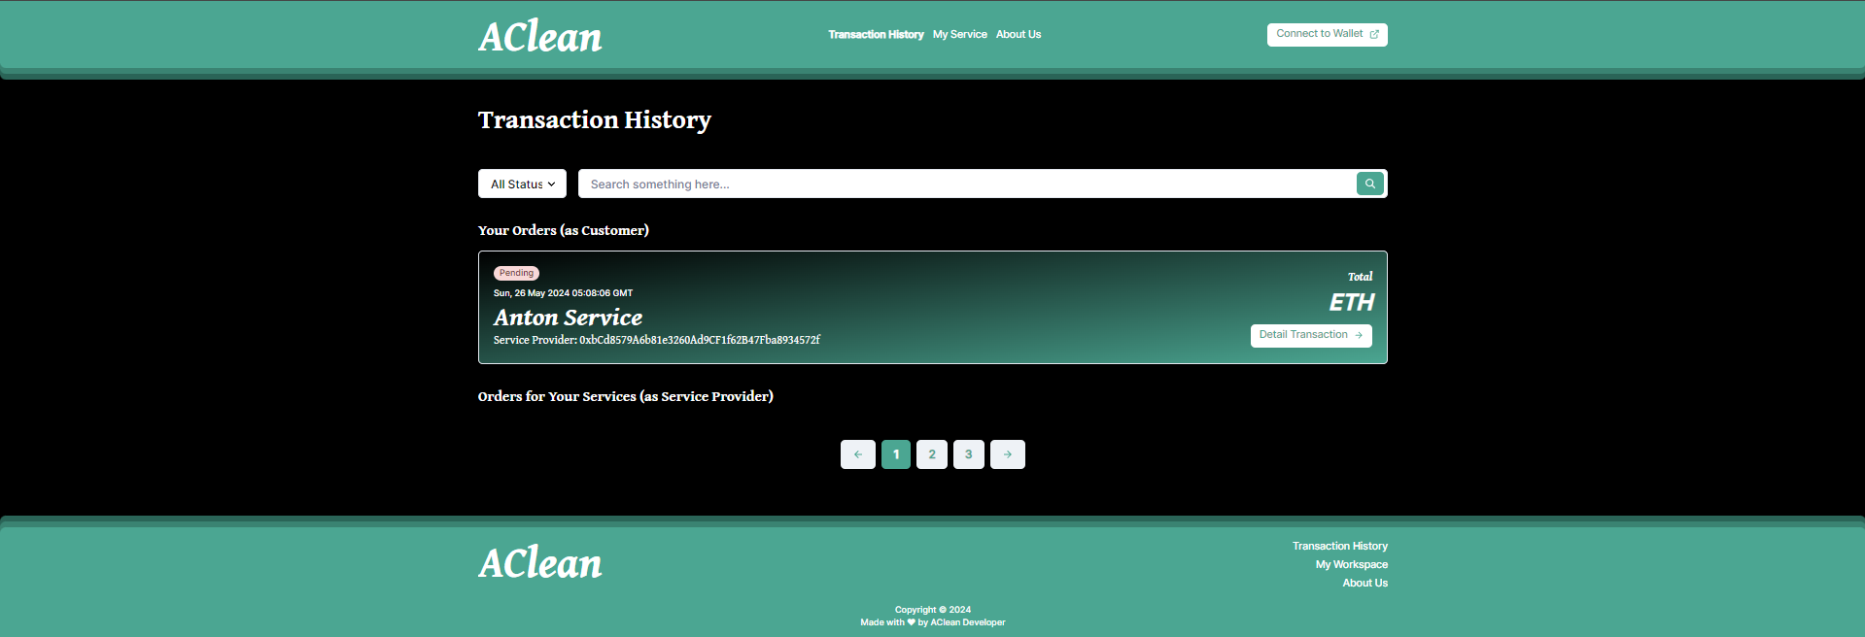

Image 4.6 Transaction History Pending Status

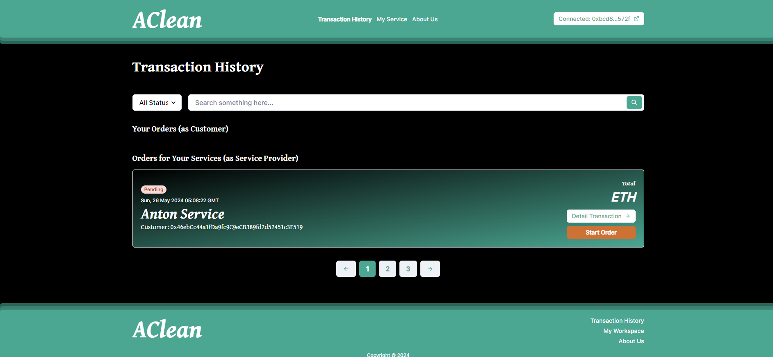

Image 4.7 POV Pending at Service Provider

The AClean application effectively manages the transaction process by providing distinct views and controls for service providers and customers. When a customer places an order, as shown in Image 4.6, the order status is marked as "Pending" in the customer's view on the Transaction History page. This status indicates that the order has been successfully placed but is awaiting action from the service provider.

In contrast, the service provider's perspective, illustrated in Image 4.7, shows the same order with a "Start Order" button. This functionality is crucial as it allows the service provider to initiate the service process whenever they are ready. By clicking "Start Order," the provider changes the order status from "Pending" to "In Progress," which will be reflected on both the provider's and the customer's transaction history. This system ensures clarity and accountability, as the customer can see that their order is pending and understand that the ball is now in the provider's court to commence the service.

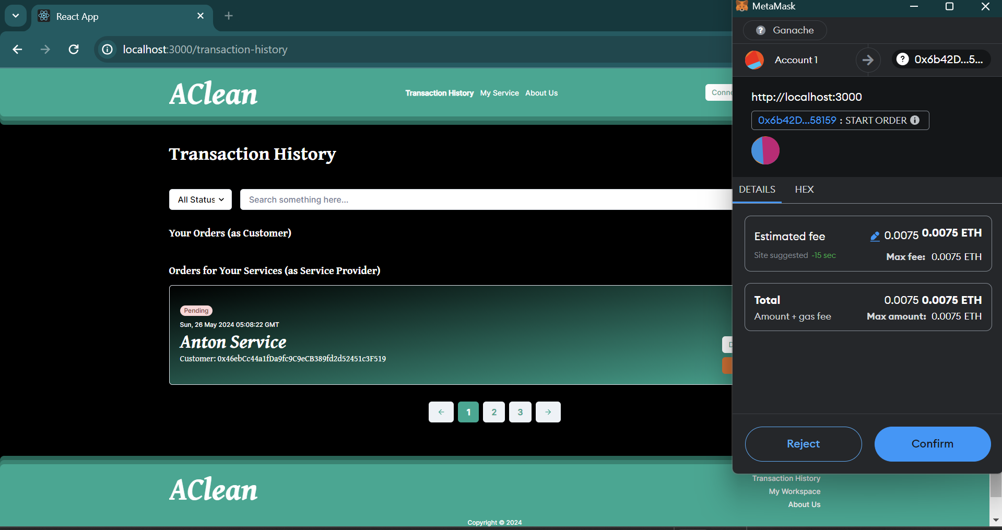

Image 4.8 Start Order Service

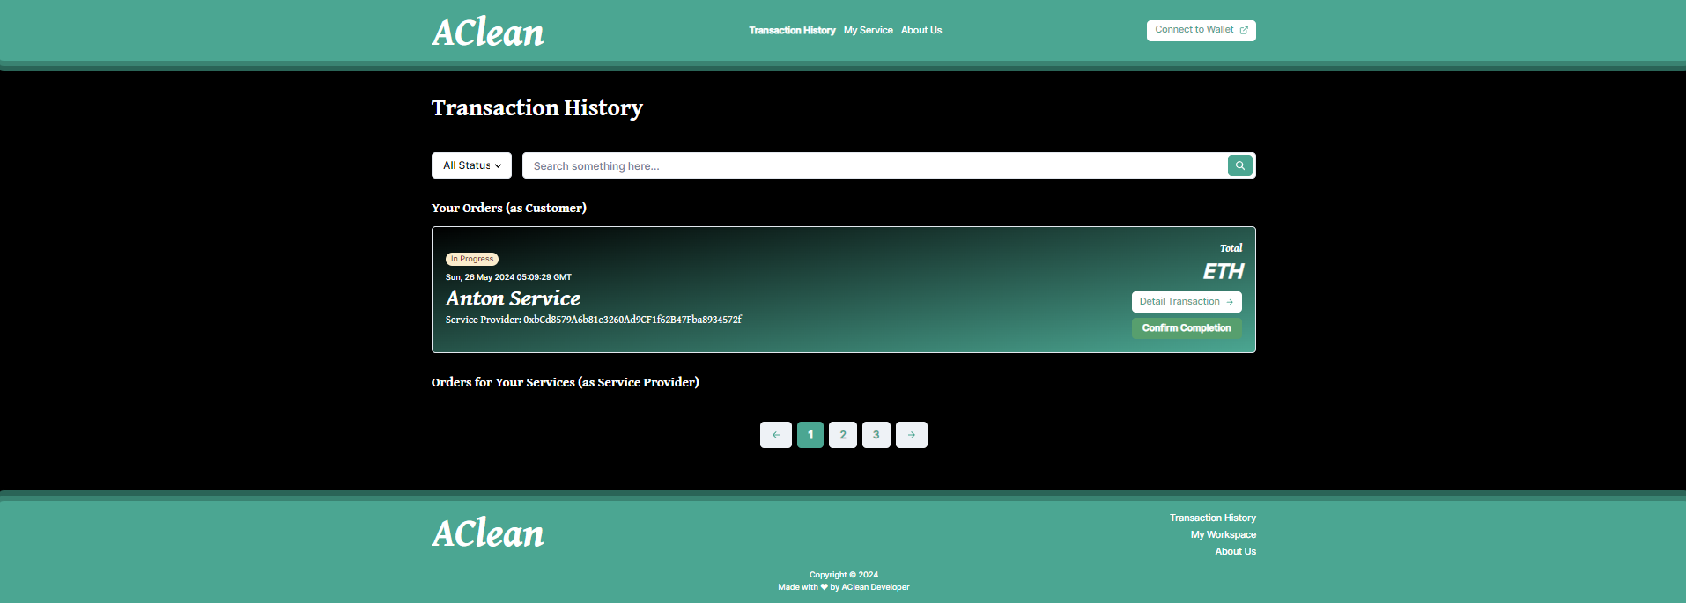

Image 4.9 Order Started

Image 4.8 and Image 4.9 depict the process where the service provider initiates the execution of a service by clicking "Start Order" in the AClean application. This action prompts a MetaMask transaction, requiring the provider to confirm and pay a gas fee to process the action on the Ethereum blockchain, thus updating the order status to On Progress'. This ensures transparency and commitment in the service provision, with blockchain verification providing a secure and accountable framework for both parties involved.

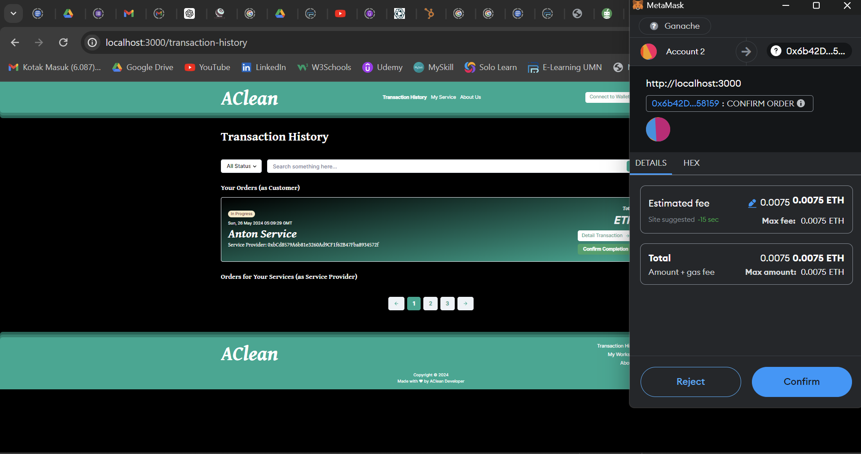

Image 4.10 Complete An Order

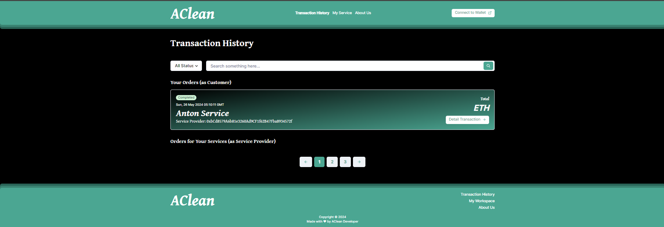

Image 4.11 Order Completed Status

Image 4.10 in the AClean application shows the functionality where a "Complete Order" button appears for the user to confirm the completion of a service once it's marked as "in progress," allowing them to finalize the service and initiate a MetaMask transaction for the secure transfer of payment to the service provider. Image 4.11 displays the order's status as "completed" in the Transaction History, confirming that the service has been satisfactorily concluded and the transaction is fully processed, ensuring clarity and accountability in the service provision and payment process.

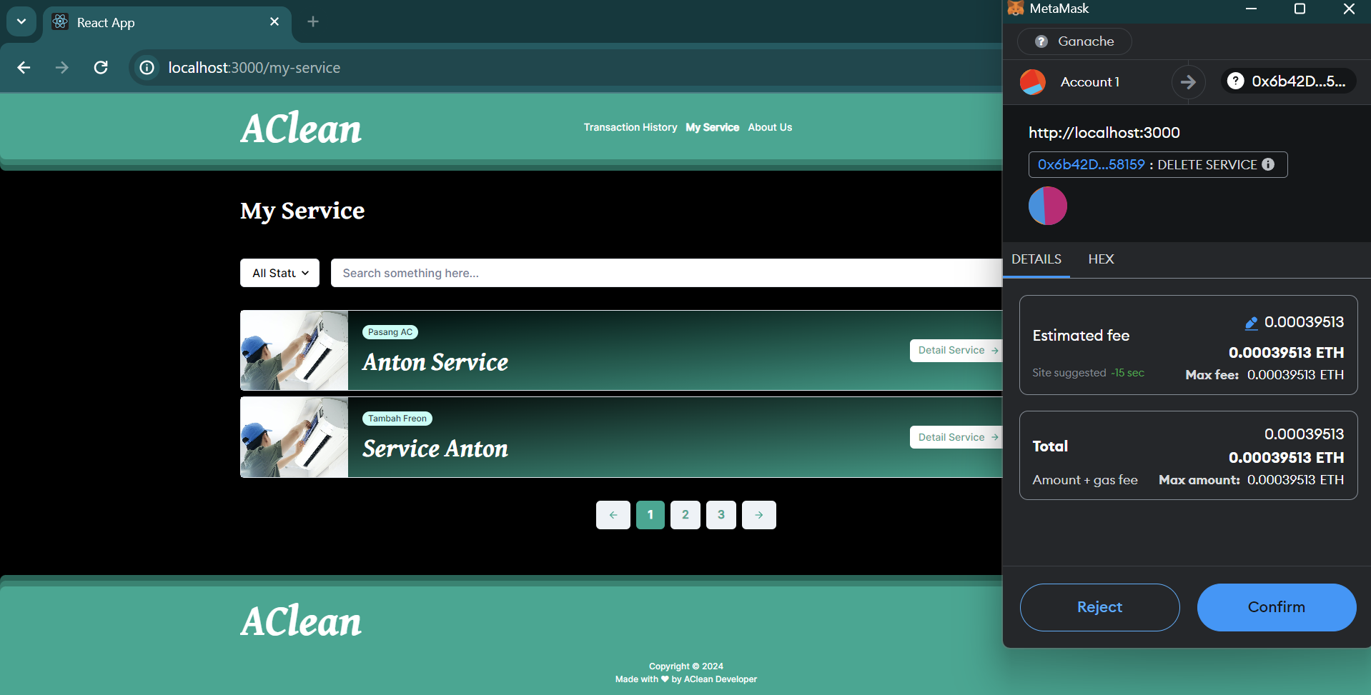

Image 4.12 Delete My Service

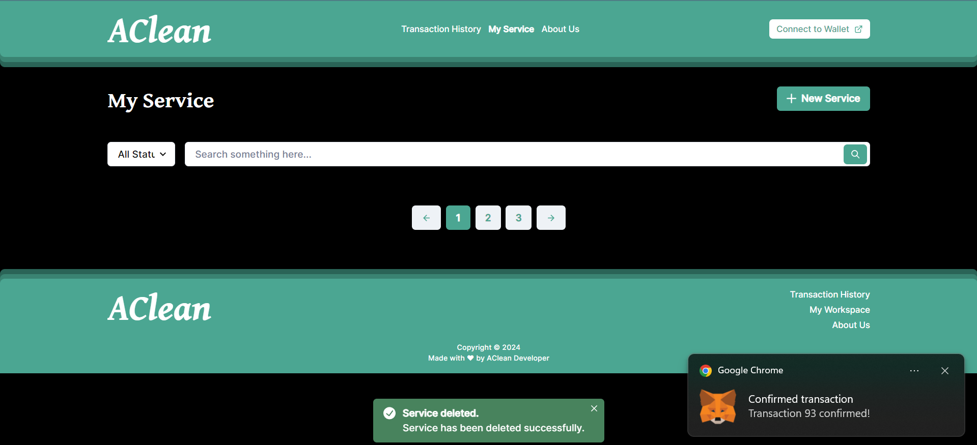

Image 4.13 Service Deleted

Image 4.12 illustrates the process within the AClean application where a service provider can delete a service listing, necessitating a MetaMask transaction to pay the associated gas fee, thereby confirming the action on the blockchain. Following this, Image 4.13 captures the moment after the deletion has been successfully processed, displaying a confirmation toast notification that states "Service deleted. Service has been deleted successfully." This sequence ensures that all deletions of service listings are not only intentional but also securely recorded and verified through blockchain technology, providing a transparent and accountable mechanism for service management.

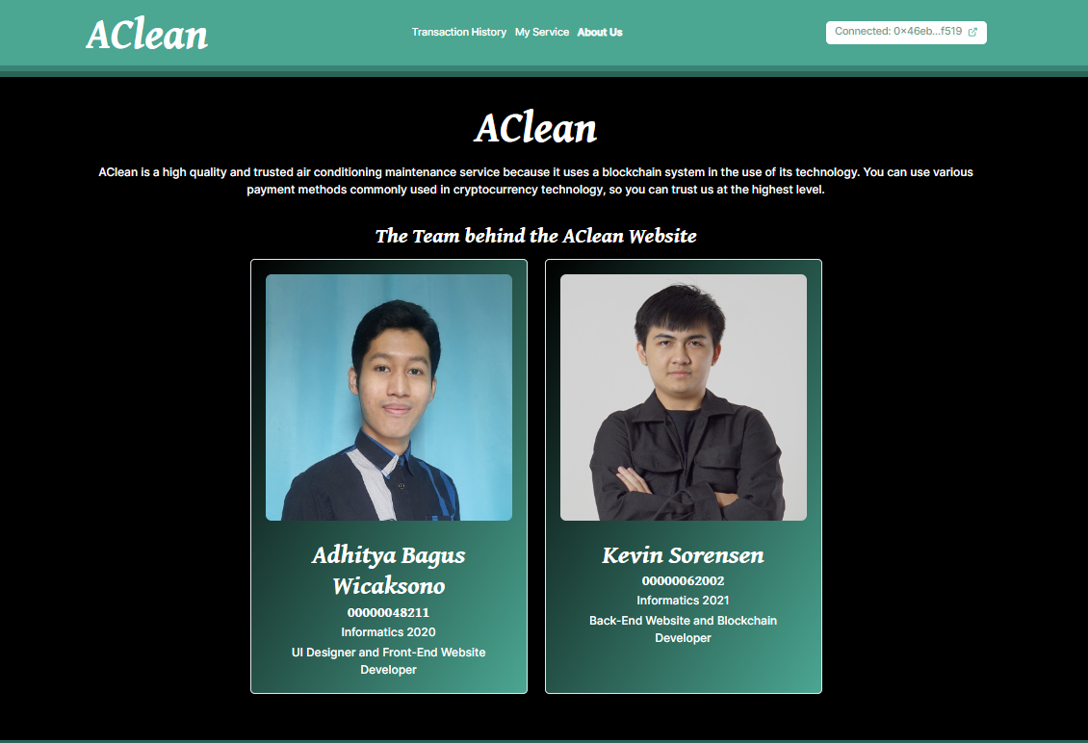

Image 4.14 About Us Result

Image 4.14 displays the "About Us" page of the AClean website, which provides a detailed overview of the high-quality air conditioning maintenance service that leverages blockchain technology for secure transactions. This page also proudly showcases the team behind the AClean project, featuring individual profiles of the key developers: Adhitya Bagus Wicaksono, an Informatics 2020 who specializes in UI Design and Front-End Website Development, and Kevin Sorensen, an Informatics 2021 who focuses on Back-End Website and Blockchain Development. This section emphasizes the team's expertise and commitment, enhancing transparency and building trust with users by highlighting the skilled individuals responsible for the platform's technological solutions.

# Work Splits

* Kevin Sorensen: 60%
  + Programmed the smart contract and flow control.
  + Connect blockchain to front end.
  + Testing with Ganache Testing Network.
* Adhitya Bagus Wicaksono: 40%
  + Designed the webpage UIs.
  + Implemented and programmed webpage functionality.

# Project Timeline

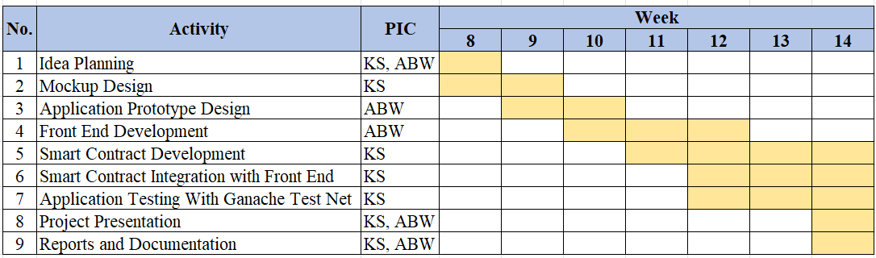

Description :

* KS : Kevin Sorensen
* ABW : Adhitya Bagus Wicaksono